Business Research Methods

Dhanraj
Research Scholar, BAP Program, MS Department,
DHA Suffa University

Socio-Economic and Personal Drivers of Renewable Energy Adoption: A Moderated Mediation Framework for Developing Countries

Overview/Background:
The article is dedicated to the usage of the wind renewable energy in the third-world countries and, specifically, in Pakistani homes (Mustafa et al., 2023; Shoaib et al., 2023). Among the most pressing issues of developing economies, one can single out the global economic crises and the growing dependency on the use of petroleum-based energy sources because these countries have to fight against the declining economies and spend a large part of the state budgets on oil and other non-green energy imports (Mustafa et al., 2023; Shoaib et al., 2023; Solangi et al., 2019). Wind energy, as an environmentally safe and sustainable source of energy, can replace sources of energy, reduce harmful greenhouse gas emissions, minimize environmental pollution, and stabilize collapsing economies because it allows the developing world to reduce its reliance on foreign oil and make more use of local renewable energy sources (Mustafa et al., 2023; Shoaib et al., 2023; Solangi et al., 2021).
These socio-economic and personal motivators are characterized as environmental knowledge (eco-literacy), environmental concern, health consciousness, and awareness of renewable energy sources, which are the key drivers of the intention to use wind energy (Mustafa et al., 2023; Shoaib et al., 2023; Yadav and Pathak, 2016). These particular determinants are assessed in this study based on an extended Theory of Planned Behavior to determine how they influence the household level decision-making process when it comes to the use of wind energy in Pakistan (Ajzen, 1991; Mustafa et al., 2023; Shoaib et al., 2023)
.
Problem Statement:

Third world countries are now crippled with severe energy shortages and financial instabilities where they import with high rates of fossil fuels, which are costly, yet the biting electricity deficits are colossal as in the case of Pakistan with a shortfall of 38.36 terawatt hours. Although wind energy can assist in filling up to 86 percent of this demand, since it is a sustainable alternative, its current contribution in the country is a pathetic 4 percent.
The crux of the issue is a large gap in research; literature mostly emphasizes the developed nations or advanced financial barriers, but psychologically and socio-economically, the factors which drive household choices in the developing worlds are health awareness and environmental literacy. In addition, the moderating effect of social influence is not well understood and ironically, the influence of these personal drivers may reinforce or dilute the effect of social influence. Until these particular triggering behavioral patterns are recognized, stakeholders will lack the ability to efficiently encourage energy self-reliance or stabilize fading national budgets.

Research Objectives:
- Understanding how health consciousness influences perceived behavioral control (PBC) and its role in renewable energy adoption.
- Exploring the influence of environmental knowledge and environmental concern on attitudes towards the environment and renewable energy adoption.
- Investigating the moderating effect of social influence on the relationships between these factors (health consciousness, environmental knowledge, etc.) and renewable energy adoption.

Scope of Research:
The research thoroughly observes intentions of households regarding adoption of renewable wind energy in developing countries while choosing Pakistan as the empirical setting. Theory of Planned Behavior has been utilized as the base of this study and the aim is to recognize that how social, economic and psychological factors influence a household’s adoption of renewable energy on domestic level. In particular the study examines the contribution of factors or variables such as environmental knowledge, health consciousness, social influence, environmental concern, cost value and awareness of renewable energy towards the adaptation of renewable energy also while analyzing the mediating effects of attitude towards the environment and perceived behavioral control. Furthermore the research addresses the question that how social influence acts as a moderator through using moderated mediation model. By choosing to focus on developing countries the study is able to analyze the gap in established literature that has primarily focused on developed countries

Significance of research

Economic and Environmental Necessity This study is essential since the developing countries such as Pakistan are experiencing energy deficiencies that threaten economies as well as natural resources (Mustafa et al., 2023). Nowadays, 64 percent of electricity generation in Pakistan is fossil-fueled, and renewable sources make up 4 percent of it (Mustafa et al., 2023). As Mustafa et al. (2023) emphasize, using the national wind and solar resources will cover 86% of the energy shortfall in the country, which will significantly decrease the financial cost of importing non-green energy and the emission of greenhouse gases. The adoption of domestic wind energy is, therefore, one of the main approaches to encouraging self-reliance, which will not only stabilize the economy but also preserve the environment over the long term (Mustafa et al., 2023).
Theoretical and Policy Contributions Theoretically, the research builds on the Theory of Planned Behavior developed by Ajzen (1991) by incorporating some new variables into it: health consciousness, environmental knowledge, and social influence (Mustafa et al., 2023). It offers an in-depth knowledge of the adoption behavior in the form of a moderated mediation framework which unveils a paradox: although social influence is a way of increasing awareness, it can also prevent the personal health consciousness to influence adoption intentions (Mustafa et al., 2023). In practice, the results provide a roadmap to legislators to bridge the so-called concern-behavior gap due to the prioritization of R&D to reduce the cost of installation and tax exemptions of off-grid projects (Mustafa et al., 2023). Based on these insights, the stakeholders can initiate specific community campaigns that can create a social norm that promotes sustainable energy (Mustafa et al., 2023).

Literature review
Mustafa et al. (2023) do not underestimate the fact that energy deficits in developing countries such as Pakistan also require a shift to wind energy as the only means to stabilize the economy and reduce the negative impact on the environment. Using an extended Theory of Planned Behavior, one of the frameworks created by Ajzen (1991) to demonstrate that intentions are the reflection of motivating factors of behavior, the study pinpoints that the central feature of the intentions to adopt is identified as perceived behavioral control (PBC) and attitude toward the environment (ATE) (Mustafa et al., 2023; Ajzen, 1991). In particular, the influence of health consciousness is an important predictor of PBC, whereas an environment-related knowledge (eco-literacy) serves as a vital predictor of a positive outlook on sustainable energy (Mustafa et al., 2023). Also, economic aspects like cost value and existence of social influence are the direct drivers, indicating that households are pragmatic with their finances and environmental utilities are beneficial in renewable technology consideration (Mustafa et al., 2023).

The paper also examines how social influence is a complex moderator which results in the strengthening of the relationship between energy awareness and adoption and contradictory weakening in the effect of personal health consciousness on intention (Mustafa et al., 2023). It is interesting to note that the sources indicate that the general environmental concern and awareness do not always translate into actual action without profound technical knowledge since most households are still reluctant to abandon the traditional national grids (Mustafa et al., 2023). As a solution to this gap, Mustafa et al. (2023) emphasize that the government should support technological improvements to make the initial investment of companies less expensive and use campaigns to create a social norm that promotes green energy among the population.

Introduction of Research Variables.
Personal and Environmental Antecedents Health Consciousness (HC) exemplifies the degree of priority of people on their physical and psychological health, which can be seen as a major driver of the decision to use environmentally friendly technologies.
- Renewness and awareness of Renewable Energy (ARE) can be explained as understanding of the particular advantages and logistical issues related to green innovations.
- Environmental Knowledge (EK), also known as ecological literacy, is a technical knowledge of ecological systems and sustainable practices. Finally, the Environmental Concern (EC) describes the type of anxiety or belief on whether humans are adversely affecting the performance of the environment.
- Socio-Economic and Contextual Drivers Cost Value Cost Value (CV) is a measure of the perceived monetary value of wind technology as compared to its high initial cost of installation.

- Social Influence (SI) can be described as the influence to adjust to peer-related norms or the spread of information in social networks. SI is distinct in this framework since it, in addition to being a direct predictor of adoption, can moderate other variable relationships to intensify or dilute them.
- Mediating and Dependent Variables Perceived Behavioral Control (PBC) refers to the perception of an individual with regard to the ease or difficulty of switching to renewable energy.
- Attitude toward the Environment (ATE) serves as a hypothetical position as far as the overall importance of environmental conservation is concerned. PBC and ATE are both critical mediators that get the personal values into the Renewable energy Adoption Intention (REAI), which constitutes the ultimate willingness and motivation of the household to adopt wind energy.

Variable relationship and hypothesis
The paper uses a developed mediated-moderation model based on the Theory of Planned Behavior (TPB) to predict the Renewable Energy Adoption Intention (REAI) among households in the developing world. The model hypothesizes that socio-economic and personal factors have a direct or indirect impact on REAI in terms of two main mediators: Perceived Behavioral Control (PBC) and Attitude towards the Environment (ATE).

Direct Relationships and Foundational Relationships.

Two mediation approaches
Health Consciousness → PBC (H1): More health conscious people will have a higher likelihood of having more control in using renewable energy.

Environmental Knowledge + ATE (H4): The higher the environmental knowledge the better positive environmental attitudes.
Nonetheless, the proposed direct relationships between Awareness of Renewable Energy and PBC (H2) and Environmental Concern and ATE (H3) were not verified.
Direct predictors of Adoption Intention.
All the predictors with the significance that were directly related to the REAI were statistically significant:
Cost Value → REAI (H5): The more advantages are perceived, the more the adoption.
Social Influence REAI (H6): adoption is facilitated by social norms
ATE REAI (H7): Intention goes up as a result of positive environmental attitudes.
PBC -REAI (H8): When perceived control is increased, adoption intention becomes stronger.
Simple Mediation Effects
Health Consciousness→ PBC→ REAI (H1a): PBC is a complete transmitter of effects of health consciousness to adoption intention.
Environmental Knowledge ATE REAI (H4a): ATE is the intermediary between environmental knowledge and REAI.
Moderated Mediation: Social Influence Role.
Mediation are conditionally modified by Social Influence (SI):
H1b (Supported): The indirect relationship between health consciousness and REAI through the mediator of PBC is weakened in the presence of high social influence, which implies that interpersonal health motivation may be lost to social conformity in developing settings.
H2b (Supported): Knowledge of renewable energy also supports the mediating impact of social influence between renewable energy awareness and the intent to use renewable energy via PBC although there is no significant direct effect of renewable energy awareness on PBC. Perceived control and adoption intention are improved through social interactions.
Other Policy-Based Moderation.
H9: The positive household level policy indicator of ATE on REAI is greater when household are knowledgeable of policy incentives. When there is awareness of government support, this will decrease the perceived financial risk allowing the positive attitudes to be converted to actual adoption intentions, providing a direct policy implication.
Data collection method
This paper adopted a primary survey-based research design to explore the intent of adopting renewable energy. The survey was conducted using a structured questionnaire that was administered to the specific targeted stakeholders such as the professionals in the corporate office, wind power companies, solar production companies and researchers of renewable energy in universities. The survey instrument has been based on validated constructs to make sure that the responses are accurate. All questionnaires were to be structured with the aim of providing cross-sectional data in terms of socio-economic and psychological variables. The measurement of responses was done based on a Likert scale to make the process precise and easy to use by the respondents.

Sampling
The study used a focused sampling strategy in order to reach 300 or more respondents who have relevant knowledge or interest in the green industry. This sample was a niche population unlike general household surveys since it was interested in environmentally friendly users and producers of renewable energy. This sampling technique was selected to obtain quality information out of the "informed users that are already in the renewable energy lifecycle. The targeted concentration on these specialized groups will guarantee that the research will capture the views of people who have the best chance of shaping the shift to the use of fossil fuels to sustainable wind energy.

Evaluation of Statistical Techniques and Model.
The analysis was done using Smart PLS 4.0 that was used to do Partial Least Squares Structural Equation Modeling (PLS-SEM). This is a sophisticated algorithm because it is selected because of its ability to test complicated moderated mediation models. The examination was conducted in two steps:
1. Measurement Model (Reliability and Validity)
Outer Loadings: The indicator loadings of the model = 0.7, which indicates that none of the items lacked the required reliability to be carried.
• Construct Reliability: Internal consistency was achieved using Cronbachs alpha, scores all which were within or above the suggested levels of the prescribed threshold.
• Convergent Validity (AVE): The value of the Average Variance Extracted (AVE) is much higher than the 0.50 criterion, which means that the constructs were converged successfully to one value.
• Discriminant Validity: The Heterotrait-Monotrait (HTMT) ratios was used to verify this and they were found to be below the conservative level of 0.85.

Abstract
The world today is experiencing acute cases of energy deficits in developing countries that are destroying national economies and leading to massive environmental degradation with the depletion of natural resources, The need to shift to renewable sources of energy (such as wind energy) is urgent because the current budgets are dwindling, and the environmental sustainability of the environment is under threat due to the use of fossil fuels. Based on the Theory of Planned Behavior, the study incorporates the variables of the health conscious, the environmental knowledge and the social influence to influence the domestic intention to use wind technology, The mediating effects between these factors are connected by the mediating positions of the ideas of the perceived behavioral control and attitude toward the environment that form an end-to-end moderated mediation framework. The research was based on the cross-sectional study of the sample comprising of 840 household responses in Sukkur, Pakistan and the statistical analysis was performed with the use of Smart PLS 4.0.

The findings of the PLS-SEM analysis reveal that the direct predictors of adoption are strong, and both Cost Value and Social Influence demote the intentions to the same degree, which is 60.8% of adoption variance, One of the most interesting observations is the so-called moderation paradox, according to which the relationships between **Social Influence** and adopting renewable energy in the first case and personal health consciousness in the second case have the opposite effect on their decision-making process, , Interestingly, even though positive attitudes were influenced significantly by the environmental knowledge (eco-literacy), general Environmental Concern and Awareness were found to be inadequate in the particular local environment, which was the subject of the analysis, ,. The study can be useful in the literature because it elaborates the use of TPB model by applying distinctive socio-economic aspects and offers the stakeholders a road map to promote the transition towards green energy sources by addressing the community and offering financial incentives. It is encouraged that governments concentrate on the approach of public-private partnerships and awareness to lessen installation cost in the short run and create a sustainability culture,
key words : theory of planned behavior, Social influence ,moderated mediation ,Environmental knowledge and Eco literacy

Data Analysis and Results

DEMOGRAPHICS
The demographic traits are gender, age, educational level, residential and occupation status.

The findings show that most of the respondents are males and then female respondents.

This is the educational qualification of the respondents. The findings suggest that most of the respondents are bachelors degree holders (151 respondents) and then those with master degree (77 respondents). Respondents who have high school education or lower education are about few (52 respondents), and those with the least number are the people with a doctoral degree (31 respondents).

Most of the respondents fall within the age bracket of 18-25 years. The proportion of respondents between the ages of 26 and 35 is relatively not so extensive with the age group of 36 to 45 having a smaller percentage in the sample. Respondents older than 45 years are the least in number.

The findings indicate that the percentage of those in the urban areas is higher than those in rural areas.

Majority of the respondents are students. The sample is also confined to employees who are in the private sector with relatively lower number of participants in the government jobs or otherwise in some business.

Model diagram

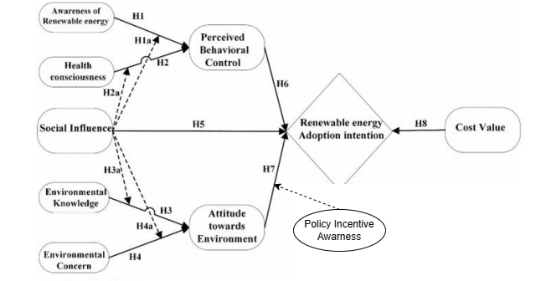
Figure 1: Model

Table 1
Constructs / Variables | Questions | Outer Loadings | Cronbach’s alpha | AVE
Awareness of Renewable Energy | ARE1  ARE2  ARE3  ARE4  ARE5 | 0.853  0.873  0.878  0.862  0.864 | 0.917 | 0.750
Attitude towards Environment | ATE1  ATE2  ATE3  ATE4 | 0.891  0.874  0.904  0.880 | 0.910 | 0.788
Cost value | CV1  CV2  CV3  CV4  CV5 | 0.859  0.883  0.871  0.850  0.858 | 0.915 | 0.747
Environmental Concern | EC1  EC2  EC3  EC4 | 0.872  0.872  0.857  0.870 | 0.891 | 0.754
Environmental Knowledge | EK1  EK2  EK3  EK4  EK5 | 0.870  0.883  0.869  0.879  0.864 | 0.922 | 0.762
Health Consciousness | HC2  HC3  HC4  HC5 | 0.883  0.863  0.862  0.886 | 0.896 | 0.763
Perceived Behavioral Control | PBC1  PBC2  PBC3  PBC4  PBC5 | 0.875  0.869  0.843  0.865  0.823 | 0.908 | 0.732
Policy Incentive Awareness | PIA1  PIA2  PIA3  PIA4  PIA5 | 0.864  0.863  0.868  0.872  0.860 | 0.916 | 0.732
Renewable Energy Adoption Intention | REAI1  REAI2  REAI3 | 0.882  0.882  0.882 | 0.857 | 0.778
Social Influence | SI1  SI2  SI3 | 0.899  0.878  0.889 | 0.867 | 0.790
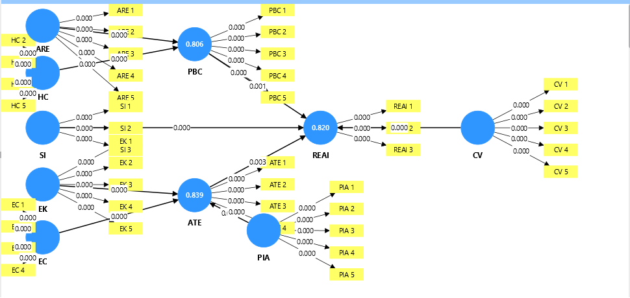

Figure 2: Measurements

R square
Table 2
 | R-square | R-square adjusted
ATE | 0.839 | 0.838
PBC | 0.806 | 0.804
REAI | 0.820 | 0.818

 | Saturated model | Estimated model
SRMR | 0.030 | 0.040
d_ULS | 0.849 | 1.485
d_G | 0.984 | 1.081
Chi-square | 1663.342 | 1747.669
NFI | 0.883 | 0.877

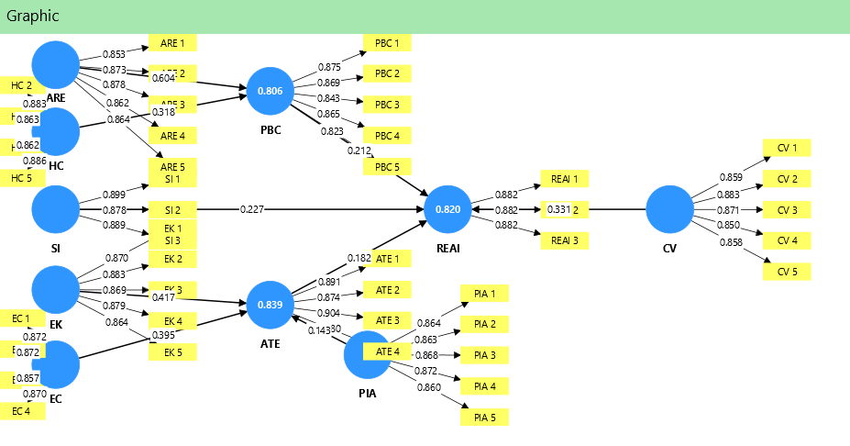
Figure 3: Hypotheses

Coefficients
Table 3 Hypothesis
 | Original sample (O) | Sample mean (M) | Standard deviation (STDEV) | T statistics (|O/STDEV|) | P values
ARE -> PBC | 0.604 | 0.604 | 0.044 | 13.680 | 0.000
ATE -> REAI | 0.182 | 0.178 | 0.060 | 3.005 | 0.003
CV -> REAI | 0.331 | 0.329 | 0.077 | 4.313 | 0.000
EC -> ATE | 0.395 | 0.394 | 0.063 | 6.297 | 0.000
EK -> ATE | 0.417 | 0.416 | 0.057 | 7.338 | 0.000
HC -> PBC | 0.318 | 0.318 | 0.046 | 6.972 | 0.000
PBC -> REAI | 0.212 | 0.216 | 0.066 | 3.241 | 0.001
PIA -> ATE | 0.143 | 0.145 | 0.048 | 2.964 | 0.003
SI -> REAI | 0.227 | 0.229 | 0.062 | 3.682 | 0.000

Description of tables

Table 1 gives the results of the measurement model. All the indicator (outer) loadings are above the recommended point of 0.70 which means good indicator reliability. The internal consistency reliability is also determined because the Cronbach alpha values of all constructs are greater than 0.70. The convergent validity is supported since the Average Variance Extracted (AVE) of each construct is more than 0.50. On the whole, these findings indicate that the presented measurement model has sufficient reliability and convergent validity, and the structural model and hypothesis testing can be considered in the following step.

The results of structural model and hypothesis testing of bootstrapping are as in Table 3. The results show that all the hypothesized relationships are statistically significant since the path coefficients are positive and the p-values are less than the 0.05 level. This implies that the hypothesis relationships in the research model are justified.

Discussion

Economic Practicality and Social Pressure.
The analysis points out Cost Value (CV) and Social Influence (SI) as the most significant direct predictors of Renewable Energy Adoption Intention (REAI), which together had 60.8 percent of the variance. This implies that the families within the developing economies such as Pakistan work at a pragmatic level; they see wind technology as a monetary endeavor with long-term saving having to match the heavy initial installations costs.
Psychological Mediations: Mediation.
The study proves that the Theory of Planned Behavior (TPB) can be successfully extended with the help of two main mediators:
• Health Consciousness (HC) → PBC: Health-conscious people have a greater level of control (Perceived Behavioral Control) to the practice of wind energy, which is considered as a means to decrease the dangerous emissions and increase the quality of the air.
• Environmental Knowledge (EK)→ ATE: "Environmental literacy A positive Attitude toward the Environment is a critical predictor of whether or not one has technical understanding of the environment, which means that one needs technical understanding to adopt eco-literacy.
The "Concern-Behavior" Gap
One of the intriguing results is that Environmental Concern (EC) and general Awareness of Renewable Energy (ARE) are statistically insignificant in having a direct effect on attitudes and perceived control.
Social Influence (SI) is a complicated two-sided sword in the moderated mediation model:
1. SI enhances the association between awareness (ARE) and adoption. It is fueled by the fact that information is being disseminated in the social networks and community interactions diminish the technical uncertainty.
2. On the other hand, high SI reduces the influence of Health Consciousness on adoption. This would make logical sense to imply a social conformity effect, in which individual health motivations are repressed to existing peer norms or economic patterns.

Implications and Contributions.
1. Policy Incentive Awareness (PIA)
Theoretical Contribution:
This paper is an extension of the Theory of Planned Behavior (TPB) with the addition of Policy Incentive Awareness (PIA) as a moderating variable. PIA bridges the gap between positive attitudes and renewable energy uptake in the developing economies by alleviating the perceived financial risk by creating awareness of government subsidies.

2. Theoretical Support and Literature Support.
The suggested framework is based on the recent literature which associates policy mechanisms and technology adoption. Prior studies highlight:
Financial literacy and the adoption of residential renewable energy (Ankrah Twumasi et al., 2022).
The significance of prioritization of policies at the state level in stimulating the use of technology (Steffen et al., 2022).
Based on this information, the framework describes the functioning of PIA, which is alleviation of perceived financial risk, thus converting positive environmental attitudes into renewable energy adoption intentions (REAI).

3. Applicability Regionally and Comparative Perspective

The results are applicable to the region and can be applied to other energy-constrained economies, including **China, India, Sri Lanka, and Bangladesh, where the awareness of the policy can boost current social and informational forces of the adoption of renewable energy.

4. Implications
The research suggests the change of general advocacy to specific financial empowerment by:
Economic incentives, such as tax exemptions, low-interest financing, etc.
And Public-private partnerships,
PIA-driven sensitization programs that focus on cost savings in the long-term.

Practical recommendation
The sources suggest that to close the 86% energy potential gap in Pakistan governments should focus on financial restructuring by incorporating tax exemption, interest free investment schemes and special tax breaks on off grid renewable projects. To decrease the initial high cost of installation, stakeholders ought to promote the development of public-private co-operations and minimize bureaucracy barriers to entice foreign suppliers, thus decreasing the high cost of initial installation with market competition and specific R&D. More importantly, as low-level awareness does not always provide stimulus to action without technical information, the sources propose introducing ecology-literacy campaigns in partnership with such organizations as the Ministry of Climate Change and the UN to convert positive attitudes toward the environment into the intentions of adopting the policy by reminding about certain policy incentives. Lastly, the development of a local culture of sustainability by conducting social campaigns and debates within the community is necessary to secure a social norm of green energy.

Suggestion to stakeholders
In developing countries such as Pakistan, the stakeholders need to shift to a strategic model of financial and technical empowerment as opposed to the general environmental advocacy as a way of bridging the concern-behavior gap. Particularly, governments and legislators must institute financial incentives like tax exemptions on off-grid projects, no-interest investment schemes, and more research and development to reduce the high initial installation, which, according to the sources, is one of the major obstacles to pragmatic and cost-sensitive households. To enhance market competition and access to technology, the authorities must, through enhanced public- private relations, reduce bureaucracies and taxation on foreign renewable energy companies, Moreover, since the overall environmental issue does not normally evoke action without technical knowledge, the Ministry of Climate Change and national organizations, such as the UN must initiate a campaign, known as the subsequent ecological literacy, addressing the logistical benefits and certain financial benefits of wind energy, Lastly, the stakeholders may also use the social influence by launching local campaigns and healthy community discussions to instill in the society the culture of sustainability, in effect, making renewable energy uptake a social norm,

Limitations:

This plays a key role in regards to academic integrity because as a research student, it is imperative to be aware of the limitation that comes with a study. The constraints that were related to this study were as follows:

1. Geographic and Demographic Constraints.
This study was empirically oriented to the city of Sukkur, Pakistan, which was of a specially chosen location because of the possibility of wind energy. The findings in the level of awareness and intention to adopt may therefore not be applicable in the context of the coast or other areas which have varying wind resources and socio-economic features. Besides, although the demographic data, such as age, income, education, etc were collected, the discussion of these barriers and facilitators in more specific terms was not provided, and this creates a gap in the understanding of the particular barriers and facilitation of use by these variables.

2. Methodological Design: cross-sectional vs. longitudinal.
The study design that the research used was a cross-sectional research design because the data was gathered by the use of a questionnaire that was administered over a period of one month.
The Problem: The cross-sectional researches are simply providing some insights of intentions at a particular point in time.
The Longitudinal Research is Necessary: As a student researcher, I should like to point out that not everything that one intends to do is turned into a long-term behavior. The future research should be longitudinal to track the follow-up of the households planning to install wind energy to determine whether they have actually installed it in several years.

3. Problems with the Introduction of New Research Elements
The insertion of the new element, dubbed Policy Incentive Awareness (PIA), and the expansion of the Theory of Planned Behavior (TPB) posed an academic difficulty.
Theoretical Grounding: Addition of new variables should be fully justified in order to avoid compromising the notion of internal consistency of the model.
4. Problems in Data gathering.
The challenges that we encounter in data collection methods are the high response rate assurance and Common Method Variance (CMV) bias prevention.
Data Integrity: To possess an informed data, the study was targeted on specific stakeholders.

Conclusion

This paper focuses on identifying the factors that determine the adoption of the household wind energy in Pakistan by expanding the Theory of Planned Behavior (TPB) using a moderated mediation model. The results describe the relationship between environmental awareness and adoption intentions in developing economies; this is accomplished through the conversion of psychological, social, and economic factors.
The findings show that the strongest direct predictors are Cost Value (CV) and Social Influence (SI), which suggests that financial factors and social regulations play a crucial role. The perceived behavioral control (PBC) and the attitude toward the Environment (ATE) are the important mediators, where health consciousness impacts adoption via PBC and environmental knowledge (eco-literacy) but not general concern produces pro-environmental attitudes.
. Moreover, a condition called as Policy Incentive Awareness (PIA) becomes a critical condition when positive environmental attitudes will lead to adoption intentions by mitigating the perceived financial risk.
The adoption of renewable energy in Pakistan is very low though the country has a significant potential of the same. The paper finds that successful diffusion necessitates replacement of general advocacy by specific monetary incentives, technical empowerment and awareness programs based on eco-literacy with domestic renewable energy as a strategic course towards energy security, economic stability, and national self-sufficiency.

References
Mustafa, S., Zhang, W., Sohail, M. T., Rana, S., & Long, Y. (2023). A moderated mediation model to predict the adoption intention of renewable wind energy in developing countries. PLoS ONE, 18(3), e0281963..
Shoaib, A., Malik, J., & Dhanraj. (2025).Socio-Economic and Personal Drivers of Wind Energy Adoption: A Moderated Mediation Framework for Developing Countries. DHA Suffa University.
Ajzen, I. (1991 ) The Theory of Planned Behavior. Organizational Behavior and Human Decision Processes, 50, 179–211.

Sources Supporting "Policy Incentive Awareness" (PIA)
Ankrah Twumasi, M., Asante, D., Fosu, P., Essilfie, G., & Jiang, Y. (2022). Residential renewable energy adoption: Does financial literacy matter? *Journal of Cleaner Production, 361, 132210.
Oosthuizen, A. M., & Inglesi-Lotz, R. (2022). The impact of policy priority flexibility on the speed of renewable energy adoption. Renewable Energy, 194, 426–38.
Steffen, B., Karplus, V., & Schmidt, T. S. (2022). State ownership and technology adoption: The case of electric utilities and renewable energy. Research Policy, 51(6), 104534.
Ghosh, D., & Banerjee, I. (2018) A Fuzzy based Analysis for Identifying Public Awareness in Renewable Energy Uses: A Case Study of Kolkata, India. Asian Journal of Research in Social Sciences, 8(3), 71–85.
He, P., Lovo, S., & Veronesi, M. (2022). Social networks and renewable energy technology adoption: Empirical evidence from biogas adoption in China. Energy Economics, 106, 105789.
Irfan, M., Elavarasan, R. M., Hao, Y., Feng, M., & Sailan, D. (2021). An assessment of consumers’ willingness to utilize solar energy in China: End-users’ perspective. Journal of Cleaner Production*, 292, 126008.
Hair, J. F., Jr., Hult, G. T. M., Ringle, C. M., & Sarstedt, M. (2021).A primer on partial least squares structural equation modeling (PLS-SEM) Sage publications.
Sekaran, U., & Bougie, R. (2019).Research methods for business: A skill building approach (8th ed.). Wiley.
SmartPLS 4 Ringle, C. M., Wende, S., and Becker, J.-M. (2022). "SmartPLS 4." Oststeinbek: SmartPLS http://www.smartpls.com.

Appendix
Questionnaire
(See Attached Questionnaire)

